|  |  |  |
| --- | --- | --- |
| **Problem Chosen** A | **2021 MCM/ICM Summary Sheet** | **Team Control Number** 2123246 |

## Magical fungi: An important role of the ecosystem

## **Abstract**

As an important part of ecological environment, fungi are worthy of further study. This paper focus on the interaction of multiple fungi, effect of humidity on fungal growth and the breakdown of ground litter and woody fibers through fungal activity by stepwise modeling.

With the help of some reasonable assumptions, such as the ecological environment is limited, we built our model according to the most basic ecological principles. Differential equations are main tools and statistical methods help us to abstract the relationship between variables from the data. Some necessary factors such as moisture tolerance, competitiveness and wet niche width were introduced into the basic Logistic model. We also managed to link the growth rate of the fungus to the decomposition rate of wood fiber.

Representative simulating situations were discussed which is helpful to solve practical problems. We used Gaussian distribution to study how short-term random environmental fluctuations and seasonal changes affect fungal growth respectively. The decomposition efficiency of fungi is mainly determined by the growth rate and humidity makes it fluctuate up and down in short term while seasonal changes have a more significant effect in the long run.

Then we took it a step further, studying how environmental issues such as Global Warming and desertification affect fungi and ecosystems. Study of fungal growth in different climatic conditions, such as tropical, arid or semi-arid regions tells us that humid climates is more suitable for fungi to grow. What’s more, we found through simulations that biodiversity promotes the recycling of carbon and stability of ecosystems.

We also analyzed the sensitivity, strengths and weaknesses of the model. Being too sensitive to some parameters is a defect of our model. At the same time, lacking in measured data, it’s difficult for us to carry out accurate numerical fitting of parameters, so we can only study the development trends.

**Keywords:** Fungi; Wood decomposition; Ecosystem; Biodiversity; Climate change; Environmental problems

## **Contents**

Abstract 1

Contents 2

1. Introduction 3

1.1 Background 3

1.2 Problem restatement 3

1.3 Problem analysis 3

2. Assumptions and symbols 5

2.1 Assumptions 5

2.2 Symbols 5

3. Analysis and modeling 6

3.1 Fungal growth and interaction model based on Logistics model 6

3.2 Relationship between fungal activity and wood decomposition 9

3.3 Summary for this chapter 10

4. Trends in population evolution under environmental influence 11

4.1 Influence in the short term 11

4.2 Influence in the long term 13

4.3 The impact of environmental problems 15

4.4 Discussions in several special climates 16

4.5 Summary for this chapter 18

5. Further discussion 19

5.1 Discussion on the role of biodiversity 19

5.2 Sensitivity analysis 20

5.3 Strengths and weaknesses 21

Learn about fungi 22

Reference 24

## **1. Introduction**

### 1.1 Background

The carbon cycle which refers to the carbon in the earth's biosphere, lithosphere, hydrosphere and atmosphere circulates with the movement of the earth. It is a vital component for life on the planet. Part of the carbon cycle includes the decomposition of compounds, allowing carbon to be renewed and used in other forms. One key component of this part of the process is the decomposition of plant material and woody fibers, during which fungi can break down lignocellulose into glucose, carbon dioxide and water. [5]

### 1.2 Problem restatement

* Describe the interactions between fungi with different growth rates and different moisture tolerances under the influence of environment.
* Decomposition model of lignin fiber in the presence of multiple fungi.
* Examine the model's sensitivity to the rapid change of the environment, further to determine the overall impact of climate change.
* Find out the suitable environment for the growth of fungi.
* Predict the role and importance of biodiversity.

### 1.3 Problem analysis

Fungi are critical to the carbon cycle. Studying factors that affect its wood fiber decomposition rate can help us better predict the carbon cycle around the world.

Recent study has found that slow-growing fungi decompose wood slower and are more capable to live in a harsh environment, while fast-growing and competitive fungi tend to live in more favorable environments and can decompose wood more quickly. [6] Other studies have explored the effects of fungi on Global Warming and other species, showing that fungi play an important role in the ecosphere.

These interesting results attract us to dig deeper into this question, which will also be used as a reference throughout our study.

In this case, we are required to develop a model that can describe the interaction and joint decomposition of multiple fungi under environmental effects, which can be abstracted as below:

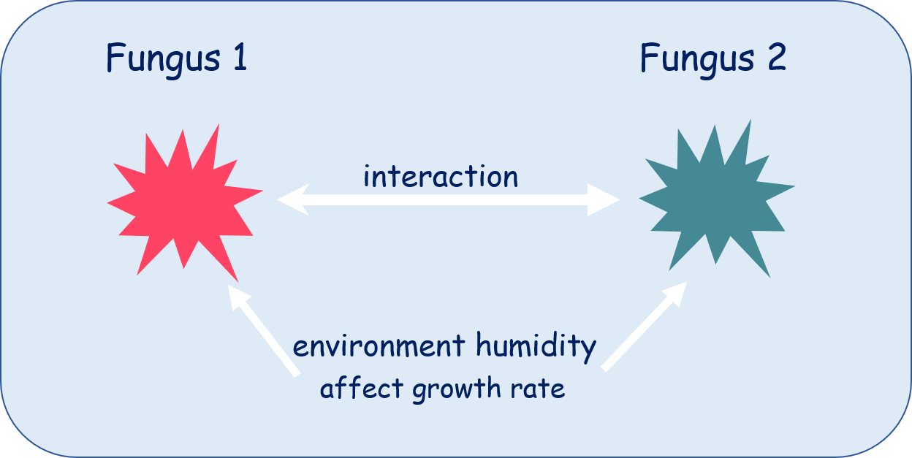

Figure 1 Diagram of the model

How to implement this model and ensure that it works? First, we need to solve the problem of population growth. Fungi, as a population, must be subject to basic knowledge of biology, which leads us to use Logistics model. But this is far from enough, we need to bring various factors into our model supported by data. Secondly, what is the specific relationship between fungal growth and wood decomposition? This is where view of energy becomes particularly important.

In the research process, we need to refer to a large amount of literature and reliable data to obtain the correct model. However, we shouldn’t focus too much on specific value, but pay more attention to its development trend, and discover the essential principle by setting some typical simulation situations.

Finally, we should try to use the model to explain some practical problems to make our research more meaningful and learn more from it.

## **2. Assumptions and symbols**

### 2.1 Assumptions

First at all, we make some basic assumptions and explain their rationales.

* All species are evenly distributed and there is no killer such as penicillium in the study area.
* Environmental resources are limited.
* The substrate of fungal decomposition is all lignocellulose.
* The growth rate is linearly related to the rate of energy acquisition.
* Fungi’s competitive ability is directly proportional to the ability of an individual obtaining resources per unit of time.

**Justification:** Fungi’s success in colonization depends on their ability to use lignocellulose and on their competitive/combative ability. [1]

* Only humidity factor is considered among all environmental factors and assume that fungal growth rate is linearly related to humidity.

**Justification:** There is significant correlation between relative humidity $RH$ and fungal growth rate ($r=0.095 p<0.05$) and $RH$ has a greater effect on fungal growth than environment temperature. [2] Other factors like PH value or atmospheric pressure are much more minor in our study.

### 2.2 Symbols

Table 1 Symbols mentioned in this paper

|  |  |  |
| --- | --- | --- |
| Symbol | Definition | Unit |
| $$t$$ | Used to indicate time | $$s$$ |
| $$N$$ | Fungal population size | - |
| $$r$$ | Natural growth rate of fungal population | - |
| $$K$$ | Environmental tolerance | - |
| $$α_{mn}$$ | Blocking effect of $m$ on $n$ | - |
| $$v$$ | Humidity influence factor on population growth rate | $$s^{-1}$$ |
| $$RH$$ | Relative humidity | - |
| $$MNW$$ | Moisture niche width | - |
| $$S$$ | Sensitivity of a fungus to humidity | - |
| $$DEC$$ | The rate of decomposition | $$s^{-1}$$ |
| $$D_{0}$$ | Natural decomposition rate | $$s^{-1}$$ |

## **3. Analysis and modeling**

### 3.1 Fungal growth and interaction model based on Logistics model

**Basic model**

There’s a population growth model under ideal conditions, which is the simplest case. Given the initial population size and natural growth rate $r$, development of the entire population can be described.[3]

$$\begin{aligned}\left\{\begin{aligned}\frac{dN(t)}{dt}=rN(t) \\ N\left(0\right)=N_{0}\end{aligned}\right.\#\left(1\right)\end{aligned}$$

We’ve assumed that environmental resources are limited, so fungi cannot grow without limit. According to biological principles, a population will have an environmental tolerance $K$ in addition to the natural growth rate under such condition. For a single population, its quantitative evolution process can be described in this way:

$$\begin{aligned}\left\{\begin{aligned}\frac{dN(t)}{dt}=r\left(1-\frac{N\left(t\right)}{K}\right)N(t) \\ N\left(0\right)=N_{0}\end{aligned}\right.\#\left(2\right)\end{aligned}$$

These two cases discussed above can be described as J-shaped and S-shaped curves respectively, which are common tools in ecology.

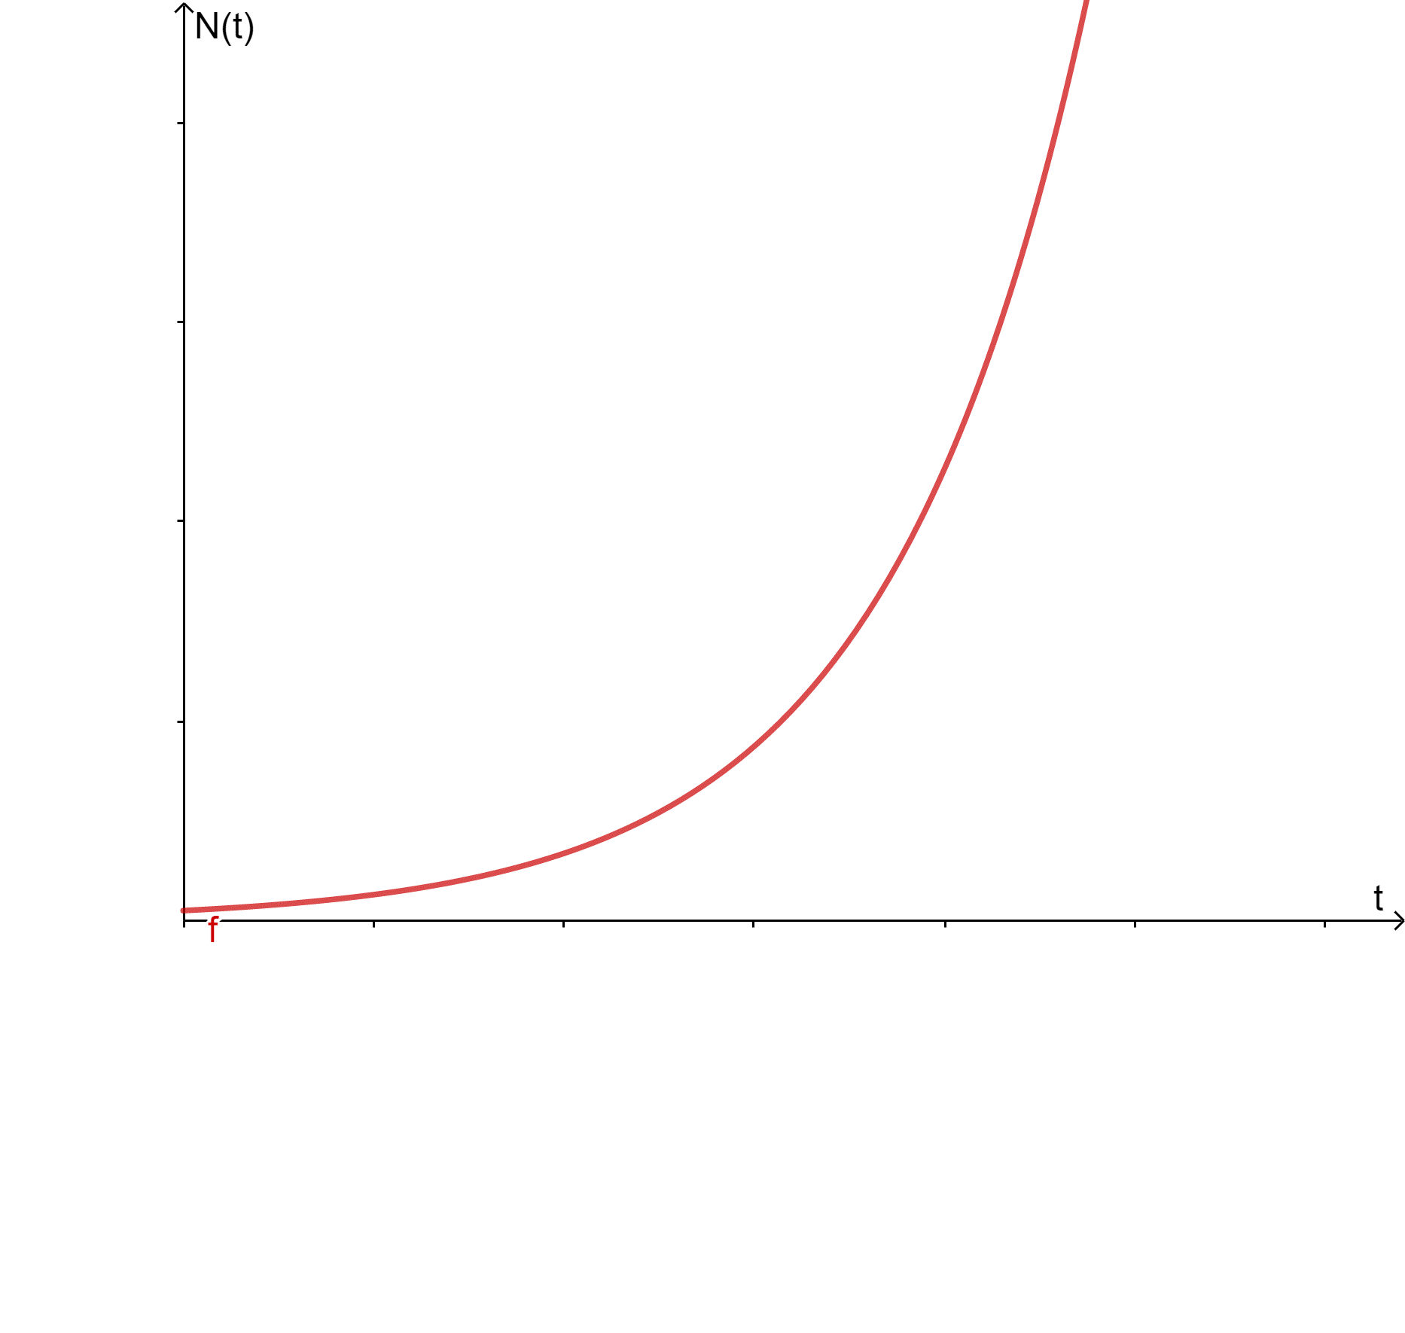 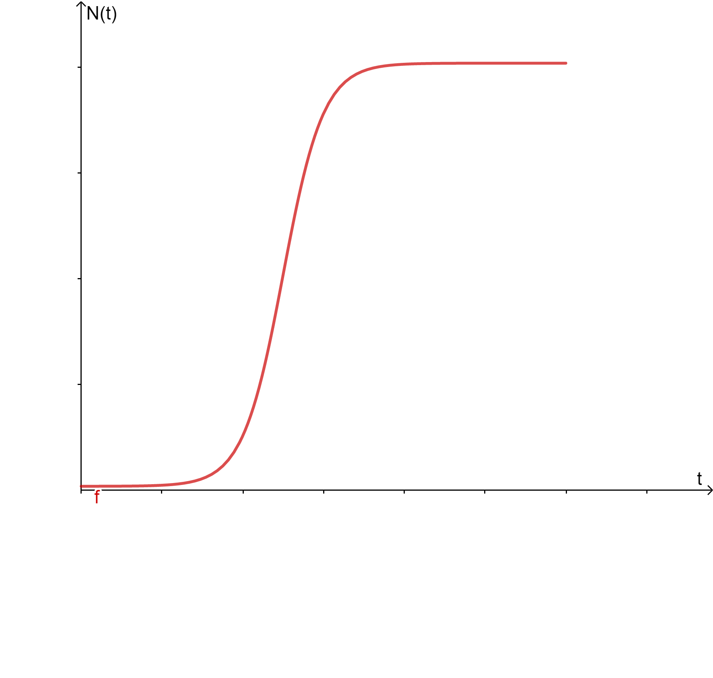

Figure 2 J-shaped curve and S-shaped curve

Quantity change formula under the interaction of two populations is as follows, in which parameter $α_{mn}$ describes their ability to acquire resources, in other words, competitive capacity or blocking effect on each other. What’s more, this formula can be easily extended to multiple populations.

$$\begin{aligned}\left\{\begin{aligned}\frac{{dN}_{1}}{dt}=r_{1}\left(1-\frac{N_{1}+α_{21}N_{2}}{K_{1}}\right)N_{1} \\ \frac{{dN}_{2}}{dt}=r_{2}\left(1-\frac{{N_{2}+α}_{12}N_{1}}{K_{2}}\right)N_{2} \\ N_{1}\left(0\right)=N_{10} N_{2}\left(0\right)=N_{20}\end{aligned}\right.\#\left(3\right)\end{aligned}$$

It is important to note that $α_{mn}>1$ means one population is so competitive that can easily cause another population’s extinction. This is something that doesn't happen very often in the context of our study which should be ignored, unless you have a fungus like penicillium.

Regardless of environment effect, here are two typical examples and experiment data is as follows:

Table 2 Parameters for two-species interaction example

|  |  |  |  |  |  |
| --- | --- | --- | --- | --- | --- |
| Example | Population | $$r$$ | $$K$$ | Blocking effect on the other | $$N_{0}$$ |
| A | 1 | 0.4 | 100 | 0.6 | 1 |
| 2 | 0.2 | 100 | 0.8 | 1 |
| B | 1 | 0.3 | 100 | 0.8 | 1 |
| 2 | 0.2 | 100 | 1.1 | 1 |

Let's analyze the results. In Example A, blocking effect between two populations is relatively small so two populations live in harmony. Though the first group grows faster, it is less competitive than the other, so it starts out with more numbers and then falls behind.

In Example B, one population is very competitive ($α>1$) while the other is relatively weak. The weaker one finally become extinct.

In Chapter 4, we’ll discuss more complicated cases where various environmental factors are considered.

 

Figure 3 Result of Example A and B

**Introduction of Environmental Impacts**

As assumed, we only take the effect of humidity into account among all environmental factors, and it’s linearly related to the fungal growth rate, namely that:

$$\begin{aligned}\frac{dN\left(t\right)}{dt}∝RH+constant\#\left(4\right)\end{aligned}$$

Then, formula (2) can be modified in the following form:

$$\begin{aligned}\begin{aligned}\left\{\begin{aligned}\frac{dN(t)}{dt}=rN(t)\left(1-\frac{N\left(t\right)}{K}\right)(v+1) \\ N\left(0\right)=N_{0}\end{aligned}\right.\end{aligned}\#\left(5\right)\end{aligned}$$

$v$ is humidity influence factor making growth rate fluctuates up and down, which can be calculated by the following expression:

$$\begin{aligned}v=S·RH\#\left(6\right)\end{aligned}$$

$S$ is a constant varying from different fungi which describes the sensitivity of a type of fungi to humidity.

$RH$ is easier to control in laboratory environment, while it needs to be determined by statistical analysis of meteorological factors in real ecosystem. [7]

The moisture niche width $MNW$ is the difference between the maximum and minimum moisture levels in which half of a fungal community can maintain its fastest growth rate. [6] It reflects the humidity tolerance that should be inversely proportional to the humidity sensitivity $S$. Ignoring the weight of constant, we derive this formula:

$$\begin{aligned}MNW=\frac{1}{S}\#\left(7\right)\end{aligned}$$

It's worth mentioning that when $S→0$, namely $MNW→∞$. At this point, humidity has no effect on fungal growth, so equation (5) is reduced to equation (2) which shows that our model is logically self-consistent.

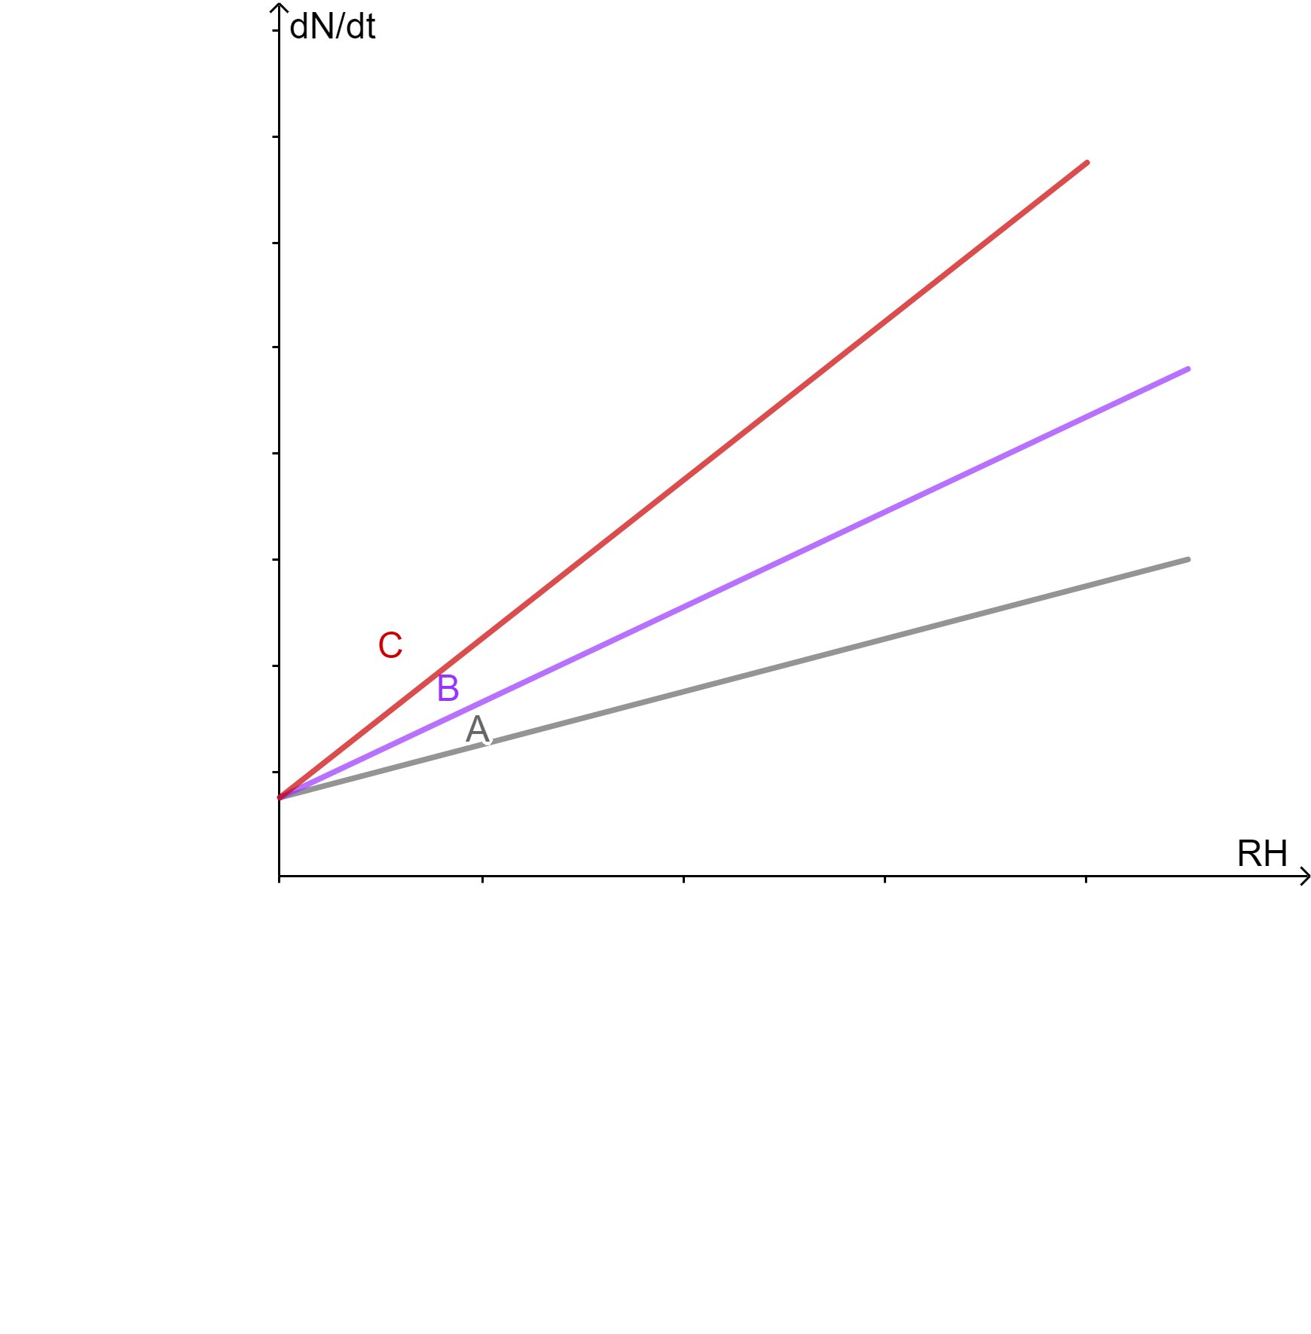

Figure 4 Relationship between fungi growth rate and humidity

Relationship between growth rate and humidity can be directly seen from the figure above. For the three populations C, B and A, slope of the straight line which indicates the sensitivity $S$ decreases gradually, so the width of the wet niche $MNW$ increases gradually, but at the same time, the growth rate also decreases gradually. This is consistent with existing experiments.

**Conclusion**

In this section, based on reliable experimental data and reasonable assumptions, we successfully described the growth and development rules of fungal population under the influence of humidity. The model can also describe the interaction between populations.

In the next part, we will relate the growth of fungi to the decomposition of wood to derive a complete and practical model.

### 3.2 Relationship between fungal activity and wood decomposition

At present, the major fungi that can degrade lignocellulose are white rot fungi, brown rot fungi and soft rot fungi. [4] Now let’s take white rot fungi for example to explain the decomposition process.

Like other organisms, fungi break down organic matter to get energy to support their own growth and reproduction. It is a very complicated process which is shown below:



Figure 5 White rot fungi’s decomposition process

For us, however, it’s not necessary to study the detailed chemical process. According to ecological knowledge, the process of fungi breaking down matter to obtain energy can be simplified to the following form:

$$\begin{aligned}{{(C}_{6}H_{10}O_{5})}_{n}+6nO_{2}\underset{→}{ fungi }6nCO_{2}+5nH_{2}O+Calories\#\left(8\right)\end{aligned}$$

We have assumed that the rate of energy acquisition is directly proportional to the rate of growth, and we deduced from this equation that energy acquisition rate is also directly proportional to the rate of decomposition. We can draw following conclusion:

The rate of decomposition $DEC$ is directly proportional to the rate of fungal growth and the mycelium density. This conclusion is also a further inference of Nicky Lustenhouwer et al work (2019) based on reasonable assumptions. This relationship can be described in this way:

$$\begin{aligned}DEC∝\frac{dN\left(t\right)}{dt}\#\left(9\right)\end{aligned}$$

As we’ve assumed, all species are evenly distributed in the study area, so when $i$ populations of fungi are present, the total decomposition efficiency is the linear combination of every population’s $DEC$.

$$\begin{aligned}DEC=D_{0}+\frac{{dN}_{1}\left(t\right)}{dt}+\frac{{dN}_{2}\left(t\right)}{dt}+⋯+\frac{dN_{i}\left(t\right)}{dt}\#\left(10\right)\end{aligned}$$

$D_{0}$ is the natural decomposition rate.

### 3.3 Summary for this chapter

Starting from the most basic population growth model, introducing environmental capacity $K$ and blocking ability factor $α_{mn}$, we got a more practical model which can show the interaction between populations. Discussion on the scope of $α_{mn}$ is also valuable.

Additionally, the conclusion that relative humidity $RH$ is directly proportional to the growth rate is obtained referring to relevant experiments. Next, influence factor $v$ is introduced to describe environmental influence and we have an effective way to calculate $MNW$.

Now we have a model of how fungi interact and grow together under the influence of $RH$. Aiming to link the growth of fungi to decomposition of wood, we use energy as a bridge and conclude that growth rate of fungi is directly proportional to the efficiency of wood decomposition rate $DEC$.

Considering that there must be multiple populations acting together when wood is decomposed in practice, according to our hypothesis, way to solve $DEC$ in the presence of multiple populations is derived.

With the help of our model, we will discuss some more complex and practical cases in following chapters.

## **4. Trends in population evolution under environmental influence**

In this chapter, we will focus on effects of weather on fungi and their decomposition rates. The discussion is major about situations existing two populations, and that of multiple populations can be generalized from this.

Studies have shown that most fungi do not grow when relative humidity is below 60%. [8] When it’s lower than that value, the growth rate will be negative and population number will decline. This can help us to generate a more reasonable relationship between growth rate and humidity that will be discussed later.

In dealing with the observation of short-term trends, we assume that relative humidity fluctuates only slightly over a given average relative humidity. In dealing with the observation of long-term trends, we assume that relative humidity has a large seasonal variation.

### 4.1 Influence in the short term

As mentioned above, humidity in the short term has randomness and it fluctuates around its average randomly. How can we get humidity data for simulation? As we know, the Gaussian distribution is widespread in nature, and change of humidity obeys it as well.

We can generate 35 random points that follow the Gaussian distribution near the average humidity (Here we take 75%). Because changes in natural humidity should be continuous we can use spline interpolation to fit these points, and a smooth humidity curve can be obtained.

Next, we will conduct two sets of experiments using three populations with different characteristics as follows. Then simulate a situation where three populations interact.

Notably, the second of these three populations is particularly sensitive to humidity, while other two groups were not.

Table 3 Data from experiments involving environmental factors

|  |  |  |  |  |  |  |
| --- | --- | --- | --- | --- | --- | --- |
| Time span | Population | $$r$$ | $$K$$ | Blocking effect on the other | $$N_{0}$$ | $$S$$ |
| 30 days | 1 | 1 | 1500 | 0.4 | 2 | 1 |
| 2 | 1.3 | 1000 | 0.6 | 2 | 3 |
| 3 | 0.8 | 1500 | 0.7 | 2 | 0.8 |

**Population 1 and population 2**

$α_{mn}$ of both populations is less than 1, so they should be able to finally achieve symbiosis. How will humidity affect them?

The following is the changing curve of humidity during this period, growth curve and the change of total decomposition rate, where $D_{0}$ is 30.



Figure 6 Humidity, growth curve and decomposition rate

This is a very interesting result. Two populations that very different from each other end up with similar number. Though population 2 grows faster at the beginning and is more aggressive to population 1 ($α_{21}>α_{12}$), its environmental carrying capacity is lower than population 1, which means that population 1 still has enough resources to reproduce and catch up with population 2, and eventually the two reach a convergence.

Carefully observing the growth rate image, we can also find that growth rate of population 2 will also shake with the relative humidity, and because population 2 is more sensitive to the change of humidity, it’s fluctuation in growth rate can be more easily seen.

What’s more, in the short term, decomposition rate reached the highest in the period of rapid population growth, and then reached a stable level where decomposition rate fluctuated mainly under the influence of humidity.

**Population 1 and population 3**

Now let's look at population 1 and population 3 together



Figure 7 Humidity, decomposition rate and growth curve

Due to the absolute competitive advantage, fungus 3 resisted the oppression of the rapidly growing fungus 1 at the beginning, and occupied all the living resources in the end, making fungus 1 extinct quickly and become the winner in the fungus battle. However, since neither of them is particularly sensitive to changes in humidity, it is difficult to see the influence of humidity jitter on growth rate from the figure.

In this case, a population goes extinct. Although the decomposition efficiency under such a small fluctuation is not much different from that of the two populations acting together, it can be predicted that when the environmental changes become even more dramatic, this community will suffer a devastating blow. This will be discussed further in Chapter 4 and 5

But consistent with what has been said before, this kind of cut-throat competition is rare in the context of our study. We're not going to consider that in the rest of the discussion.

**Three populations interaction**



Figure 8 Three populations’ growth curve

When more different populations interact with each other, the internal mechanism becomes more complex, and the whole system becomes more stable, less affected by the environment, and is in a dynamic equilibrium.

From this more practical situation, we can also see the importance of biodiversity. The specific interaction processes within this system are not the focus of our attention.

### 4.2 Influence in the long term

In this part, we’ll simulate changes in population numbers and decomposition rates of different fungi over a long period of time.

For the long-term trends in interactions between different types of fungi, we’ll only talk about the interaction in the case of coexistence of two fungi and we have assumed that humidity has seasonal fluctuations.

In addition, we modified the effect of humidity on growth rate as a piecewise linear function to describe the growth situation of fungi under 60°C. The graph of the function is as follows:

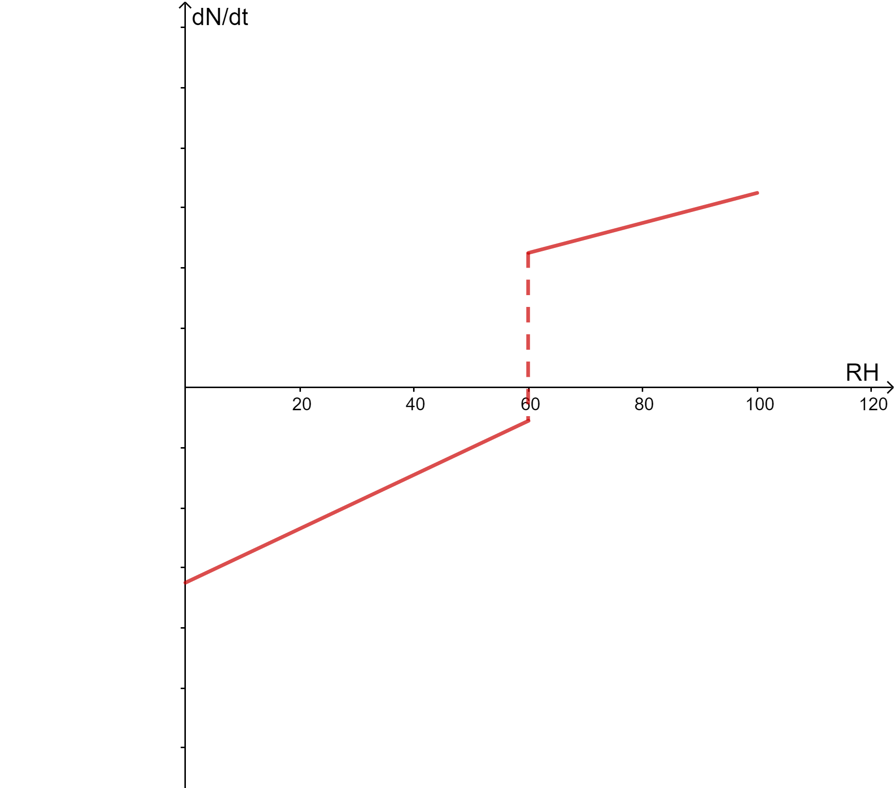

Figure 9 Modified effect of humidity on growth rate

First, under constant humidity conditions, we find that the decomposition rate is maintained at natural decomposition rate and both populations’ number are stable.



Figure 10 Long-term trend with constant humidity

Second, to simulate periodic changes of humidity with the season, we assume that fungi 1 and 2 are planted in New Delhi, India, just before the arrival of the summer rainy season in June, and the changes in the first two years, namely 730 days are as follows.

The humidity data of New Delhi, India, were obtained [9] and interpolated using spline.



Figure 11 Results from humidity data in New Delhi

As we can see, at the beginning of the summer rainy season, humidity rises rapidly and fungi 1 and 2 both grow at an alarming rate and reach their peak. After the summer rainy season, humidity decreases significantly, and the population is affected and decline slowly.

In winter, under the influence of *Northern Indian Ocean Monsoon Circulation*, the humidity increases obviously, and the fungi obtain a suitable condition for growth again. A brief second wet period is followed by another sharp drop in humidity, during which there’s a slow drop in fungi, awaiting the arrival of the following summer rainy season.

Situations in following years are like the first year.

### 4.3 The impact of environmental problems

**Global Warming**

Let's take a broader view. From 1980 to 2020, the global ocean humidity has decreased by approximately 0.4%, while global land humidity has decreased by approximately 0.85%. [10] It may have something to do with Global Warming. Based on this, we estimate average annual declines of about 0.01% (ocean) and 0.021% (land), which are extremely small changes that cannot be captured in our model. But what if Global Warming continues? What will happen when the environment changes even more?

**Desertification**

In addition to Global Warming, there are many thorny environmental problems that also have a dramatic impact on the ecological environment. Let's take desertification as an example, with fungi as the protagonist, and discuss the impact on ecosystem.

In the simulation we accelerated the process of desertification. Suppose that the average monthly relative humidity drops slowly over two years, until by the end of the second year it is half as low as it was at the beginning of the first year, and there are still seasonal changes in humidity. Here’s what we get:



Figure 12 Results from simulated land desertification experiment

Humidity changes quickly and there are no suitable conditions for fungus to grow after the first summer rainy season. This indicates that this ecosystem has been seriously disrupted.

**Changes in the environmental governance process**

Afforestation plays an important role in solving environmental problems. When forest expands, what will happen to fungi?

Let's assume that the average monthly relative humidity has risen slowly for two years, and by the end of the second year it has risen to 120% of what it was at the beginning of the first year. Here's what we get:



Figure 13 Results from simulated afforestation experiment

At the arrival of the second summer rainy season, due to the rise in humidity, the population increased faster than in the first summer rainy season, and the population declined more slowly after the rainy season, indicating that the ecosystem is more stable in the second year than in the first. It can be predicted that with the further increase of humidity in the future, the fungal population will stabilize.

The results show that environmental governance is effective in restoring the ecological environment, but it is also a slow process that requires long-term efforts. Therefore, we should attach great importance to environmental protection.

### 4.4 Discussions in several special climates

We have discussed the effects of short-term fluctuations, long-term seasonal variations, and environmental problems on fungi. We know that different regions have different climates, and climate affects the characteristics of humidity changes throughout the year. What kind of effects does it have on fungi? What kind of environments do fungi prefer to live in? Let's find out the result.

As you can see from the picture on the next page, London area with the highest humidity had the fastest growth rate, followed by Singapore. However, number of the fungal population does not fluctuate as much as New Delhi discussed before, in which the decomposition rate of wood fiber mainly determined by the natural decomposition rate. What’s more, Semi-arid and arid areas were not suitable for the growth of fungi.

Data sources see [11]~[14].

**Semi-arid region**



Figure 14 Simulation of semi-arid region (Lhasa as an example)

**Arid region**



Figure 15 Simulation of arid region (Bilma as an example)

**Temperate region**



Figure 16 Simulation of temperate region (London as an example)

**Tropical rainforest region**



Figure 17 Simulation of temperate region (Singapore as an example)

### 4.5 Summary for this chapter

In this chapter, we discussed the effects of various environments on the growth of fungi and the rate of wood decomposition. Cases of short-term fluctuations, long-term seasonal variations, and global climate trends are all considered. Discussion on the growth of fungi in desertification and its control is also very thought-provoking. Fungal growth rate in various climatic regions show us the environments that fungi prefer. Fungi grow faster and decompose wood more efficiently in areas affected by monsoon climates.

The importance of biodiversity came to light during this study. The higher the biodiversity, the more stable the ecosystem is, and the more resilient it is to environmental disturbances. More specific theoretical analysis will be discussed in Chapter 5.

## **5. Further discussion**

### 5.1 Discussion on the role of biodiversity

The main factor that affects the decomposition rate is the growth rate of fungi and fungal populations can reach a stable state very quickly with appropriate conditions. Therefore, the discussion in the short term is more representative. Here, we consider the overall efficiency of the decomposed system over a period of 35 days.

Now we describe how the diversity of fungal communities of a system impacts the overall efficiency. Total decomposition efficiency is given by the following equation:

$$\begin{aligned}φ= \int_{0}^{t_{0}}{DEC dt} \#\left(11\right)\end{aligned}$$

First, a comparative analysis was made between the coexistence of two species of fungi and that of only one species left at the end. The results were observed as follows:



Figure 18 Coexistence situation and one population extinct situation

When reaching a steady state, the overall decomposition efficiency of two populations in symbiosis is better than that of only one population survived. After several statistics and taking the average value, the symbiotic situation won with a 3% advantage, indicating that diversity of fungi accelerated the decomposition of woody fiber. In contrast to the symbiotic case, the results are more erratic when only one population survives, indicating that the fungal diversity makes the fungal system more resistant to interference when the external factors change.

The case of multiple fungi can be extended on this basis.

From a macro point of view, in a stable situation, the effect of biodiversity on the circulation of materials in nature is: the more diverse the species, the faster and more efficient the material cycle. And the stronger the anti-jamming ability. The role of biodiversity will become more apparent as the environment changes more greatly.

### 5.2 Sensitivity analysis

Sensitivity analysis is a method to study and analyze the sensitivity of state or output changes of a system or model to changes in system parameters or surrounding conditions.

Next, we’ll analyze the sensitivity of the model to rapid fluctuations in the environment. The parameters were adjusted based on fungi 1 and 2.

Table 4 Basic data to be adjusted

|  |  |  |  |  |  |
| --- | --- | --- | --- | --- | --- |
| Population | $$r$$ | $$K$$ | Blocking effect on the other | $$N_{0}$$ | $$S$$ |
| 1 | 1 | 1500 | 0.4 | 2 | 1 |
| 2 | 1.3 | 1000 | 0.6 | 2 | 3 |

We are mainly concerned with the population size and growth rate of fungi, and the rate of decomposition and the efficiency of decomposition can be computed from them.

**Sensitivity analysis of $r$**



Figure 19 Sensitivity analysis of $r$

As you can see from the figure, with respect to the change of $r_{i}$, the population quantity and growth rate change greatly. In other words, the model requires high precision of parameters.

**Sensitivity analysis of $S$**



Figure 20 Sensitivity analysis of $S$

The sensitivity of $S$ is appropriate when changing within a reasonable range. It causes the growth curve to vary slightly around the original curve. In addition, its sensitivity can be controlled by its weight, which can be obtained by fitting in practical application. What’s more, the higher the sensitivity to humidity, the higher population growth rate which agrees with the existing experiment result.

### 5.3 Strengths and weaknesses

**Strengths**

* As many problems as possible are solved in a simple way, and the differential equations are easily solved using mathematical software.
* Based on experimental data, the model is derived strictly with strong self-consistent logic.
* The model describes the interaction of fungi under the influence of the environment and the decomposition of wood by fungi well.

**Weaknesses**

* Due to the limited available experimental data, it is difficult to fit the parameters and test the validity of the model.
* The simulation of the real environment is a little rough.
* It requires a lot of computing force and is prone to non-convergence.
* Being too sensitive to some parameters such as the growth rate $r$.

## **Learn about fungi**

**F**ungi are a kind of eukaryotic, sporogenic, chloroplast-free eukaryotes. Contains molds, yeasts, mushrooms, and other fungi known to humans.

More than 120,000 species of fungi have been discovered. Fungi are separate from animals, plants and other eukaryotes. Fungal cells contain chitin, which produces spores through asexual and sexual reproduction. They inhabit soil or dead plant matter and play crucial roles in the mineralization of organic carbon.

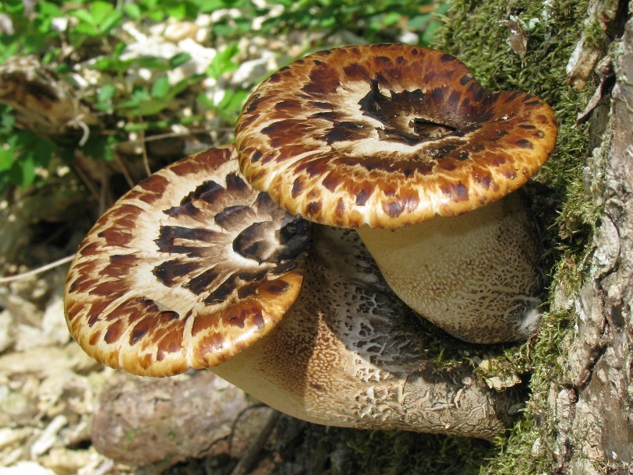

Polyporus squamosus taken by Dan Molter

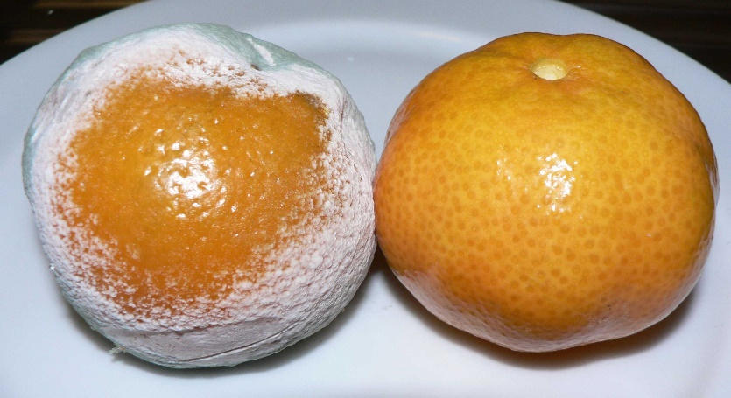

penicillium mold on mandarin oranges

CC BY-SA 3.0 [15]

Many fungi are plant pathogens, and a few cause diseases of animals, including humans. Certain fungi also establish symbiotic associations with many plants, facilitating the plant’s acquisition of minerals from soil, and many fungi benefit humans through fermentation and the synthesis of antibiotics.

**Morphological** **structure and reproduction of fungi**

The structure of fungal vegetative growth stage is called trophic structure. The vegetative bodies of most fungi are branching filaments, and the single filaments are called hypha. Many mycelium are grouped together under the name of mycelium. The form of mycelium growing on the substrate is called colony. When viewed under a microscope, mycelia are tubular, have cell walls and cytoplasm, and are colorless or colored. Mycelium can grow indefinitely, but the diameter is limited, generally 2-30 microns, the largest up to 100 microns. The hyphae of lower fungi without septum are called septic hyphae, while the hyphae of higher fungi with many septum are called septic hyphae. In addition, the vegetative bodies of a few fungi are not filaments. They are plasmodium with no cell wall and variable shape or ovoid single cells with a cell wall. Fungi that live on plants often spread as mycelium between or through the cells of the host.

Fungi reproduce by asexual means in one of three ways: (1) by the growth and spread of hyphal filaments; (2) by the asexual production of spores; or (3) by simple cell division, as in budding yeasts. Most fungi also form sexual spores, typically as part of an elaborate life cycle.

**The role of fungi in carbon cycling in ecosystems**

The carbon cycle describes the process of carbon exchange throughout the earth's geochemical cycle and is a vital component for life on the planet. Part of the carbon cycle involves the decomposition of compounds so that the carbon can be renewed and used in other forms. A key component of this process is the decomposition of plant materials and wood fibers.

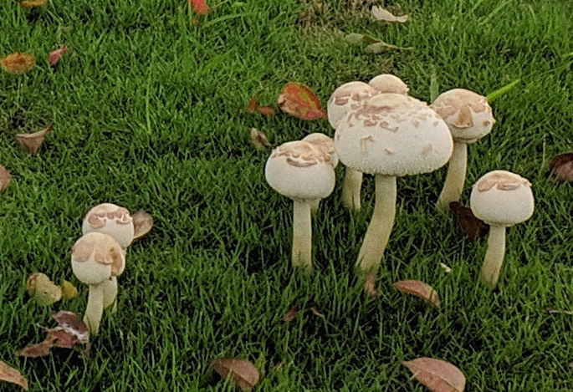

Taken by Team #2123246

Some of the key agents in decomposing woody fibers are fungi.

A major ecological activity of fungi, especially basidiomycetes, is the decomposition of wood, paper, cloth, and other products derived from these natural sources. Lignin, a complex polymer in which the building blocks are phenolic compounds, is an important constituent of woody plants, and in association with cellulose it confers rigidity on them. Lignin is decomposed in nature almost exclusively through the activities of certain basidiomycetes called wood rotting fungi. Two types of wood rot are known: brown rot, in which the cellulose is attacked preferentially, and the lignin left unmetabolized, and white rot, in which both cellulose and lignin are decomposed. The white rot fungi are of major eco- logical importance because they play such a key role in decom- posing woody materials in forests. Fungi break down lignocellulose into glucose, carbon dioxide and water.

It can be concluded from the above that fungi play a very important role in the carbon cycle of the ecosystem.

**Further reading**

The important role that fungi play in ecosystems has attracted the attention of researchers.

Recently, Team #2123246 from MCM/ICM has conducted a partial study of this process. They established a mathematical model to describe the connection between a fungal system and the rate of wood fiber decomposition. They found that the abundance of fungal diversity can enhance the rate and efficiency of fiber decomposition, which in turn can improve the efficiency of carbon cycling in ecosystems. By that analogy, fungal community with various fungi can accelerate the circulation of materials and the thermal entanglement of the whole ecosystem.

## **Reference**

1. J. Hiscox, J. O'Leary, L. Boddy. Fungus wars: basidiomycete battles in wood decay[J]. Studies in Mycology, 2018 volume 89: 117-124.
2. Liu Wenbi, Liu Yingyun, Liao Jie, Zhang Xiaoming. Study on the relationship between temperature and humidity and fungal contamination in air conditioning system [J]. Environmental Science and Technology, 2009, 22(03): 22-25.
3. Cramer, J.S., The Origins of Logistic Regression (December 2002). Tinbergen Institute Working Paper No. 2002-119/4.
4. Zuo Sasa. Degradation mechanism of corn straw by white rot fungi and its application[D]. China Agricultural University, 2019.
5. Lian Bin, Hou Weiguo, The role of fungi in terrestrial ecosystem carbon cycle[J]. Quaternary Sciences, 2011, 31(3):491-497.
6. Nicky Lustenhouwer, Daniel S. Maynard, Mark A. Bradford, Daniel L. Lindner, Brad Oberle, Amy E. Zanne, and Thomas W. Crowther, "A trait-based understanding of wood decomposition by fungi," Proceedings of the National Academy of Sciences of the United States, May 13, 2020.
7. Fang Peng, Zheng Zijun, Mo Fang, Ma Xianju, Ma Lianmin.Analysis of relationship between soil moisture and meteorological factors [J]. Journal of Xichang University (Natural Science Edition),2019,33(02):86-93.
8. Anna-Liisa Pasanen and Jukka-Pekka Kasanen and Sirpa Rautiala and Marko Ikäheimo and Jouko Rantamäki and Hannu Kääriäinen and Pentti Kalliokoski. Fungal growth and survival in building materials under fluctuating moisture and temperature conditions[J]. International Biodeterioration & Biodegradation, 2000.
9. https://mausam.imd.gov.in/
10. https://www.metoffice.gov.uk/hadobs/monitoring/dashboard.html
11. http://www.stats.gov.cn/tjsj/ndsj/2020/indexch.htm
12. https://weather-and-climate.com/average-monthly-Humidity-perc,Bilma,Niger
13. https://data.gov.sg/dataset/relative-humidity-monthly-mean
14. https://www.london.climatemps.com/humidity.php
15. https://commons.wikimedia.org/w/index.php?curid=532857